Dynatrace Smartscape – Detailed Notes with Diagram

# 1. What Is Smartscape?

Smartscape is Dynatrace’s real-time environment topology map that visualizes applications, services, processes, hosts, and datacenters. It automatically builds an interactive visual graph without manual setup, showing both horizontal (e.g., service-to-service) and vertical (e.g., app to host) dependencies.

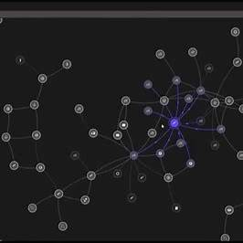

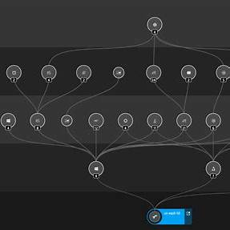

# 2. The 5 Layers of Smartscape

Smartscape topology includes:  
1. Applications – User-facing web/mobile apps  
2. Services – Business logic services  
3. Processes – Processes executing services  
4. Hosts – Servers or VMs  
5. Datacenters – Cloud/physical infrastructure

# 3. Key Features & Visualization

• Automatic discovery via OneAgent  
• Visualizes horizontal & vertical dependencies  
• Detects process-level TCP/IP connections  
• Active/inactive lines (dashed = timed out)  
• Filters, overlays, and drill-down capability

# 4. Interactive Drilling & Troubleshooting

• Click nodes for entity overviews  
• Explore cross-tier dependencies  
• Highlighted problems in red  
• PurePath, logs, metrics directly accessible

# 5. Smartscape on Grail & DQL Integration

Smartscape topology is stored in Grail, accessible via DQL for advanced use:  
Examples:  
 smartscapeNodes "HOST"  
 smartscapeEdges "calls"

# 6. Hands-on Steps for Working with Smartscape

1. Open Smartscape via left menu  
2. Choose layer (App, Service, etc.)  
3. Zoom/pan to explore  
4. Use filters (e.g., hide inactive)  
5. Enable 'Show problems' for alerts  
6. Click a node to drill down  
7. Export or automate with API/DQL

# 7. Why Smartscape Matters

• End-to-end visibility  
• Quick root-cause analysis  
• Fully automatic  
• Microservice and cloud-native ready  
• Integrates with DQL and automation tools

# Summary

Smartscape is the core visualization and mapping engine in Dynatrace. It delivers a dynamic, real-time map of your environment that supports deep insight, fast troubleshooting, and scalable observability.